Sept Tuesday to Friday: 13, 20, 27 travelling – stopover Bury St Edmunds
Maidstone 69 miles, London Tfl, Boreham Wood 16.5, Bury St Edmunds 73 miles,

First half term
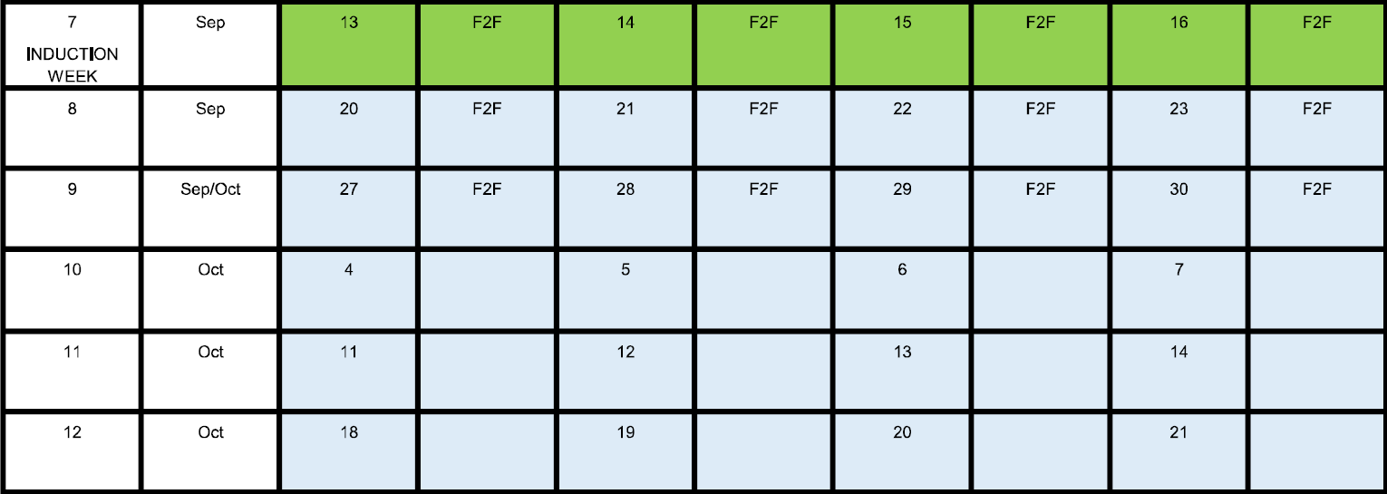
Subjects
 | Aim | Assessment
Mathematics for engineering technicians | 1 Be able to use algebraic methods  2 Be able to use trigonometric methods and standard formulae to determine areas and volume | One assignment – two weeks for online delivery
Principles and applications of electronic devices and circuits | 1 Understand the function and operation of diodes, transistors and logic gates  2 Be able to build and test operational amplifier-based analogue circuits
Electronic measurement and testing | 1 Understand the function, features and characteristics of electronic measurement and test equipment  2 Be able to select and use electronic measurement and test equipment to make meaningful measurements on an electronic circuit
Communications for engineering technicians
Engineering project
Electronic fault-finding

Second half term
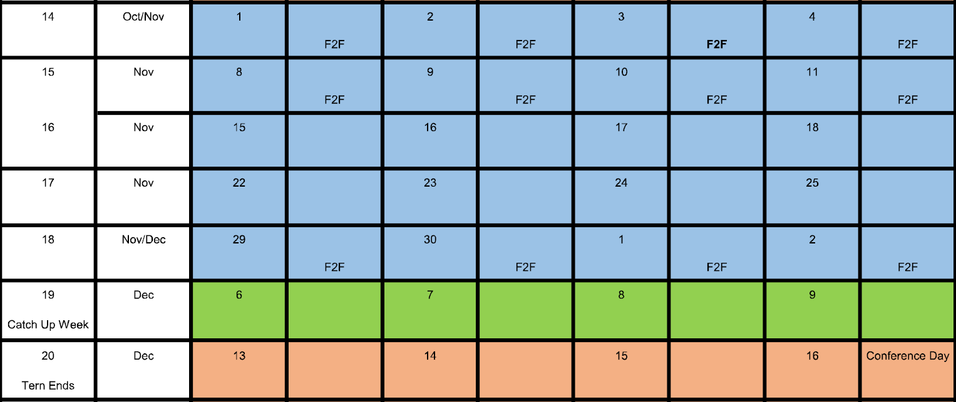
 | Aim | Assessment
Unit 3 Mathematics for engineering technicians | 3 Be able to use statistical methods to display data  4 Be able to use elementary calculus techniques
Unit 24 Principles and applications of electronic devices and circuits | 3 Be able to build and test combinational and sequential logic circuits  4 Be able to use computer-based simulation software packages to construct and test the operation of analogue and digital circuits
Unit 30 Electronic measurement and testing | 3 Know the principles of calibration and configuration of electronic test equipment  4 Be able to select and use virtual test instruments and software to make measurements and analyse measurement data.
Communications for engineering technicians
Engineering project
Electronic fault-finding

