Unit 10: Properties and Applications of Engineering Materials

Task 1)

Plain Carbon Steel
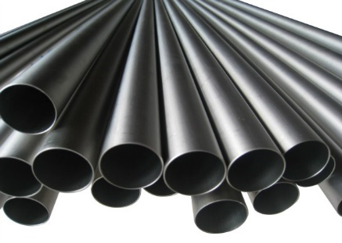
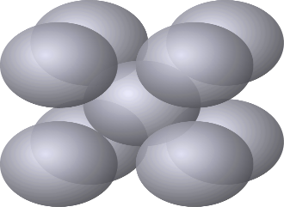
Plain carbon steel is a ferrous metal alloy which is mostly made up of iron and carbon elements. It is identified as an alloy because it is a mixture of two or more metals elements and a non-metallic element (carbon). The other elements that make this up consist of: manganese, silicon and copper. If PCS has between 0.05% and 0.25% of carbon it is considered to be low carbon steel.
When the metal compound is being made its crystal structure changes from a weak one to a strong one. It starts off with iron which is heated up to 910C, at this point the metal has an FCC (face centred cubic) structure. But when the iron is heated, it allows the carbon atoms to squeeze through and bond to the iron atoms interstitially, which when cooled, turns to a BCC (body centred cubic) structure.
BCC crystal structures don’t allow for atoms to move around much which makes for a stronger metal, which is why this metal is used a lot to make body panels for cars.

High Density Polyethylene
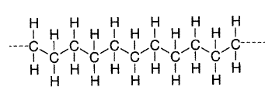
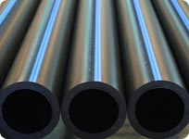
High density polyethylene is a thermoplastic which is made from petroleum. This material is used a lot in everyday products such as drinking bottles because they are extremely flexible but tough and because thermoplastics are able to be reheated and remoulded, they can be recycled many times and be used over and over again. They are however, known to have terrible properties in high temperatures and can also melt in heat. Since it is a polymer, it is amorphous, which means they don’t have a common or regular structure. But in general, polymers are made of chains of hydrogen and carbon molecules which can be regarded as crystalline.

Silicon Carbide
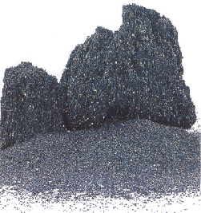
Silicon carbide is a compound made from silicon and carbon. It is referred to as a mineral and can also be identified as a polymorph which sometimes naturally occurs in nature (the bonding of both silicon and carbon). By applying sintering (compacting and sintering solid materials by heating it without melting it) silicon carbide is turned into a very hard ceramic which can then be used in car brakes, plates in bulletproof vests and even in ball type flow control valves. Silicon carbide can be either FCC or BCC.

Carbon Fibre Reinforced Polymer

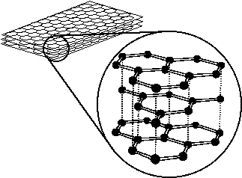
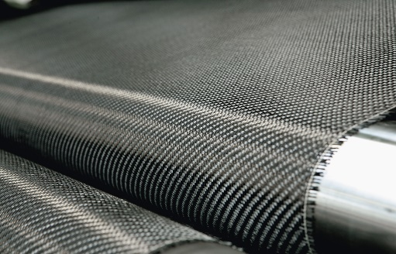
Carbon fibre is a fibre reinforced plastic which contains carbon fibres. Because of its extremely high strength to weight ratio it makes its very strong and also light material to use, which is why it is used a lot in aircraft machinery. This is a thermosetting plastic, since it has a solid network of molecules which makes it very rigid and strong also. Carbon fibre cannot be remoulded or reshaped once it has been melted once. In order to make this, sometimes a mix of both thermoplastic materials and thermosetting plastics are used together, like: polyester vinyl and nylon.

Piezoelectric
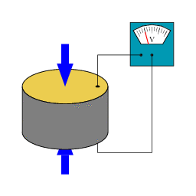
The piezo effect is a materials ability to turn applied mechanical stress into an electric charge. This process is reversible, meaning that while the material can generate an electric charge via mechanical pressure, the material can produce stress or pressure when an electric charge is applied. Piezo-electrics are used to create electric charges and are often used as a voltage power source. For example, in car cigarette lighters, pressing the button causes a hammer to hit a piezo-electric crystal which then generates electricity to light the cigar or cigarette. This process is also used to fire the airbag in a car in case there is an accident.

This is very different to dielectrics however. A di electric material is an electric insulator which when an electric field is applied, can become polarized. The dielectric material is first placed in the electric field which stops the electricity from flowing through it. The dielectric field displaces the electric flow towards the field and sends the negative current in the opposite direction. Doing this also allows the material to store energy, which is why dielectrics are very useful in capacitors and are used in radio transmission lines.

Task 2)

Austenitic Stainless Steel: Austenitic stainless steel is a metal which has austenite as its primary phase and is also made up of chromium and nickel. It has a FCC crystalline structure and is not much affected by heat making it quite strong and rigid. It is resistant to corrosion which makes it very durable and is very easy to weld.

PVC: Polyvinyl chloride is a synthetic plastic polymer (non-metal). It comes in two types, either rigid or flexible. The more plasticizers that are applied will determine how flexible or not PVC is. It can be very brittle but is very insoluble in solutions like alcohol.

Melamine formaldehyde: Melamine resin is a thermosetting plastic primarily made from melamine and formaldehyde (non-metal). It is very hard plastic which is reasonably tough and resistant to stains. It is also water resistant and would take a long period to erode.

Butyl: Butyl is a substance which derives from the chemical element butane and is often used to make rubber products (non-metal). It is extremely flexible, very stretchy and impermeable to air.

Copper: Copper is a metal which is very soft and malleable. It is ductile and has a very high conductivity rate for both heat and electricity. It does not react with water so it will not rust but it does react with oxygen.

Diamond: Diamond is a property of the carbon element configured into the diamond lattice structure (non-metal). Diamond is very hard and very transparent. It does not react to water and has a very high melting point.

CFRP: Carbon Fibre Reinforced Polymer is a fibre reinforced plastic (non-metal). It is a very tough plastic and would take a high amount of force to fracture it. It also has a high strength to weight ratio, which makes it strong and light at the same time.

Duralumin: Duralumin is a metal alloy made up of primarily aluminium, copper, manganese and magnesium. It has high temperature strength and all though it is naturally malleable it can be very tough and when heated can increase its yield strength.

Porcelain: Porcelain is a ceramic material made from heating materials such as kaolin (non-metal). Porcelain is strong, tough and very translucent. They don’t break too easily and do require a big amount of force to shatter.

Piezo crystal: Piezo crystals are crystals made from various non-metal materials and elements, for example quartz and topaz. They are very hard and tough and are very hard to break. They are very effective at directing piezoelectricity.

Task 3)
Mechanical – Tough and heat resistant
When design engineers are planning the construction of a product and/or machinery, they must evaluate the materials they want to use and the properties of said materials. A lot of engineers want to know that the machinery that they build will be made of tough materials, ones that are hard to break. This is because it would increase the life of the machine they are making since it would be able to withstand many environmental physical circumstances. Also since a lot of the machinery designers and engineers build work with electricity, they would need materials which have the heat resistant property, because electricity tends to overheat a lot. They would need to know that no matter how hot it gets, the heating point of the material would be so high that overheating electricity would not affect it and neither would heat coming from other locations like the sun would misshape it either. Like diamond for example. Carbon steel is a very tough and strong material to use, hence why engineers use it so much on trains and cars.

Physical – Weight and Aesthetics
Designers would very much be interested in the look of materials they would be using, as would the engineer since in the end they would want their product to sell, which could only be done if it is aesthetically pleasing. But looks isn’t everything. The weight would also be important since the weight can affect how fast something travels, how portable it is, or how well it works in general. They want something which is durable but is light in weight as well. Stainless steel is a good example of both of this. Because of its shiny coating, it gives the steel an aesthetically pleasing look, which is why engineers use it on buildings a lot. It is light in weight and will support the building whilst looking shiny.

Thermal – Ductility and resistance
Engineering designers know that materials can be shaped or misshaped because of heat, which in most cases will not work for them seeing as they would want a consistent structure for their product. So they would need to use materials which are highly resistant to heat so that the product would not be damaged or misshaped by any external heat source. They would also want to use something which is ductile (meaning it can have heat and force applied to it to reshape it and still have the same strength as it did before. This is key because they may want to use a material which are eco-friendly and have been recycled and been used continuously. Or just use it because they want their product to be flexible and withstand a lot of physical pressures applied to it. Thermoplastics like CFPR are exactly like this.

Electrical – Conductivity and energy storing
Designers may want to choose materials which are good conductors simply so that they can channel energy to a direct location within their machine or product. But it would also be in their interest to find materials which store electrical energy as well, so that their machine or product does not constantly have to feed off an external electrical power source, since this is not eco-friendly and expensive. Dielectric materials such as calcium copper titanate can store more than 250,000 joules of energy at a time.

Magnetic-Coercive force and permeability
Permeability in magnets is about well the material can be magnetised when it’s placed in a magnetic field where it can either be repelled or attracted by it. Design engineers would need to know if a material can be magnetised, which would provide design engineers with a variety of uses for the product. Coercive force is when an opposing magnetic intensity is applied to the material to remove the magnetism within it; this is useful for design engineers as some materials are heavily magnetised which can get in the way of working with certain materials so demagnetising those materials can be really helpful such as a interfering with electronic equipment near the material.

Task 4)
Plain Mild Carbon Steel
Plain mild carbon steel has a structure so strong that it is able to be used as a perfect material for that of ship hulls. It is used to make the hull of ships because of its excellent qualities. Mild carbon steel is extremely dense meaning that it would not be so heavy that the ship would sin rather than float. It also has a high burning point seeing as it has to reach 1349 C to burn, meaning this would have no effect in waters which are 3C to 25C. In order to make sure that the ship does not allow water in at any point, the steel which is used to build the hull goes through a process called “caulking”. Since there is no sealant that can join the steel pieces together, the edges of the steel plates are “upset” which causes faying. Once this is done the faying edge of one steel plate is forced to lay up hard against the plate which it is overlapping. This process is repeated on all hull plates to keep the steel tightly compact together.
When the steel Is placed in freezing or near freezing water, at first it has no affect. But if the ship stays there for a long period of time it will affect the ships ductility level as it becomes more brittle. It can become so brittle in fact that the temperature of the water may actually force cracks and splits in the steel if it remains in the freezing water. The effect is not long lasting, once the temperature is returned to its normal state (3C – 25C), it goes back to being quite ductile and the brittleness more or less goes away.

Duralumin
Duralumin is a metal alloy which is widely used in aerospace and aircraft machines such as passenger planes. Its main metal which it is made from is aluminium but it also comprises of copper, manganese and magnesium. It is widely used on aircraft because of its strength and toughness, meaning it would take a lot of force to deconstruct the metal and it does well with air pressure so the metal will remain intact when in the air. It also has an excellent fatigue resistance which is good because a lot of loads are applied to planes meaning it will withstand a great amount of weight.

When it is cold worked however it has a tendency to corrode and make the aluminium weaker. The reason it is so susceptible to corrosion is because of the copper which is in duralumin. So in order to stop this it has to be overlapped with a sheet of aluminium which reduces the chances of corrosion of the metal even when it is cold worked. It also has a very high strength to weight ration compared to that of normal plain aluminium and many other metals. Meaning it is very strong but light in weight as well. It has a fantastic density level which is needed since it would make more work for the plane to fly if it was a lot heavier.

It is also used a lot for aircraft because of it fatigue resistance, meaning that when it takes off and lands constantly (although it will cause some damage to the metal) it would take a long time for the impact forces of taking off and landing to take its toll on duralumin.

Polybutylene
Polybutylene is a plastic resin which is widely used for push fit plumbing construction. Polybutylene is easily mouldable and can be heated up to about 190C. It is also very easy to weld which makes it the perfect material to use for push fit plumbing. When it is under pressure it tends lot the crack because it is so flexible and malleable. Because of this it also shows very little sign of creep even when the temperatures of water are at an elevated level due to its crystalline structure and molecular weight. Temperatures above 190C however will cause it to bend and/or distort since the plastic will become a lot softer.

It is an ideal material to be used in mechanical fittings since it is very flexible and has a very good elastic recovery. So it can handle a lot of weights pressing down on it without it having much impact on it whatsoever. It is also very dense, with a density rate of 0.95g so it would but useful to machinery since it is so light and wouldn’t add a lot of weight to the machine either. PB resists chemicals like oils, fats, acids, bases and alcohols, so if any of the chemicals are used around it, it will also have no effect on it.

This could be a better replacement for copper pipes since it has many more positives if we look at the both of them. Copper is prone to rust and corrosion with water, meaning that when enough water erodes its metal layer some of the flakes would get into the water system, which could poison the water. Whereas plastic tubes do not poison water systems since they to do not erode very easily at all and won’t have parts of it flaking off into the water. Copper however does have a much higher melting point, meaning it is a lot more heat resistant.

High Carbon Steel
Shear pins are used in farming machines because they allow a specific outcome to occur once a predetermined force is applied. These shear pins are often made from high carbon steel because high carbon steel is known for its hardness, meaning it would take a lot of force for it to deform or break. However, its extra carbon makes it more brittle than that of mild and low carbon steel. Because it is so hard it makes for it to be a solid and strong material which is why they are also used as levers. But if it is misused it is likely to fracture on many cases which also includes if it is elongated to a certain point (regardless of its high yield strength. As well as being very strong and very hard to break, they are also wear resistant, meaning they would have a long life and would not have to be replaced often.

Titanium Alloy
Titanium alloy is a metal alloy which is mixed with other chemical elements and is widely used for aircraft engine components and chemical plant equipment. It is known for its tensile strength and its ability to remain extremely tough even in elevated temperatures. Its melting point is approximately 1670C and is very dense with a density of 4.51g. Singe many aircraft have a lot of high strength to weight ratios this is the ideal metal to use because of its density and resistance to heat. However, they are known to catch fire if they are rubbed against other metals which are extremely hot.

Titanium alloy has a natural crystalline structure of HCP (hexagonal close packed) but when it is heated to above 882C it transforms to a BCC structure. Although its crystalline structure changes with heat and changes back when its cooled it still retains its strength atomically. Though when it changes to a BCC it does lose a few atoms, it still does remain almost as strong as before. This is because with both formations the atoms are tightly packed together, meaning they do not have a lot of room to move around and become a lot more rigid.

The benefit of alloying titanium is that it allows for a much higher melting point. Pure titanium is heat resistant with a heating point of 882C. But this almost doubles with it is bonded with other chemicals and becomes an alloy. It is also very resistant to combustion gasses and chemicals which is why they are used so much in gas turbine engines because they can handle both the heat and will not react with the gasses that are in the engine.

References:
Wikipedia. (2016). Carbon steel. [online] Available at: https://simple.wikipedia.org/wiki/Carbon_steel [Accessed 28 Apr. 2016].

Google.co.uk. (2016). plain carbon steel - Google Search. [online] Available at: https://www.google.co.uk/search?q=plain+carbon+steel&espv=2&biw=1517&bih=741&source=lnms&tbm=isch&sa=X&ved=0ahUKEwj8sYG426_MAhWqCMAKHQDpCtcQ_AUIBygC&dpr=0.9#imgrc=IwdgR1_oKQM0qM%3A [Accessed 28 Apr. 2016].

Machinedesign.com. (2013). Crystal Structure. [online] Available at: http://machinedesign.com/basics-design/crystal-structure [Accessed 28 Apr. 2016].

Google.co.uk. (2016). bcc - Google Search. [online] Available at: https://www.google.co.uk/search?q=bcc&source=lnms&tbm=isch&sa=X&ved=0ahUKEwi1iYLr36_MAhUXM8AKHRklCasQ_AUIBygB&biw=1517&bih=741&dpr=0.9#tbm=isch&q=bcc+structure&imgrc=EBd9K3Y_3OPG4M%3A [Accessed 28 Apr. 2016].

Google.co.uk. (2016). high density polyethylene - Google Search. [online] Available at: https://www.google.co.uk/search?q=high+density+polyethylene&espv=2&biw=1517&bih=741&site=webhp&source=lnms&tbm=isch&sa=X&sqi=2&ved=0ahUKEwjC-ayz4K_MAhXBD8AKHVlqBJkQ_AUIBigB&dpr=0.9#imgrc=wPD__hpOXaN54M%3A [Accessed 28 Apr. 2016].

Wikipedia. (2016). High-density polyethylene. [online] Available at: https://en.wikipedia.org/wiki/High-density_polyethylene [Accessed 28 Apr. 2016].

Google.co.uk. (2016). polymer molecular structure - Google Search. [online] Available at:
Google.co.uk. (2016). carbon fibre reinforced polymer - Google Search. [online] Available at: https://www.google.co.uk/search?q=carbon+fibre+reinforced+polymer&espv=2&biw=1517&bih=741&source=lnms&tbm=isch&sa=X&ved=0ahUKEwjln8av6K_MAhVTF8AKHZJZDXUQ_AUIBigB&dpr=0.9#imgrc=Ex9pkt724l9HJM%3A [Accessed 28 Apr. 2016].

Google.co.uk. (2016). carbon fibre structure - Google Search. [online] Available at: https://www.google.co.uk/search?q=carbon+fibre+structure&espv=2&biw=1517&bih=741&source=lnms&tbm=isch&sa=X&ved=0ahUKEwj05bCS6q_MAhVDGsAKHed2BK0Q_AUIBigB&dpr=0.9#imgrc=hYcmOcq9BJ5snM%3A [Accessed 28 Apr. 2016].

Nanomotion. (2016). The Piezoelectric Effect - Piezoelectric Motors & Motion Systems. [online] Available at: http://www.nanomotion.com/piezo-ceramic-motor-technology/piezoelectric-effect/ [Accessed 28 Apr. 2016].

Google.co.uk. (2016). • piezoelectric - Google Search. [online] Available at: https://www.google.co.uk/search?q=%E2%80%A2+piezoelectric&espv=2&biw=1517&bih=741&source=lnms&tbm=isch&sa=X&ved=0ahUKEwjvzN3d6q_MAhVLAcAKHZD8DJ8Q_AUIBigB&dpr=0.9#imgrc=-Pi6qMU5pmkgAM%3A [Accessed 28 Apr. 2016].

Google.co.uk. (2016). • piezoelectric - Google Search. [online] Available at: https://www.google.co.uk/search?q=%E2%80%A2+piezoelectric&espv=2&biw=1517&bih=741&source=lnms&tbm=isch&sa=X&ved=0ahUKEwjvzN3d6q_MAhVLAcAKHZD8DJ8Q_AUIBigB&dpr=0.9#imgrc=-Pi6qMU5pmkgAM%3A [Accessed 28 Apr. 2016].
WhatIs.com. (2016). What is dielectric material? - Definition from WhatIs.com. [online] Available at: http://whatis.techtarget.com/definition/dielectric-material [Accessed 28 Apr. 2016].

Wikipedia. (2016). Austenitic stainless steel. [online] Available at: https://en.wikipedia.org/wiki/Austenitic_stainless_steel [Accessed 28 Apr. 2016].

Wikipedia. (2016). Polyvinyl chloride. [online] Available at: https://en.wikipedia.org/wiki/Polyvinyl_chloride [Accessed 28 Apr. 2016].

Wikipedia. (2016). Melamine resin. [online] Available at: https://en.wikipedia.org/wiki/Melamine_resin [Accessed 28 Apr. 2016].

