The simple cubic system
The simple cubic system consists of one lattice point on each corner of the cube. Each atom at the lattice points is then shared equally between eight adjacent cubes, and the unit cell therefore contains in total one atom (¹⁄₈ × 8).
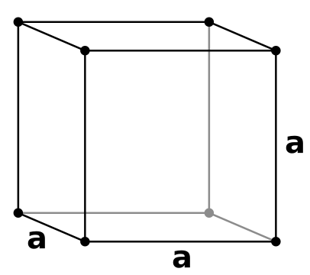
The body centered cuboid
The body-centered cubic system has one lattice point in the center of the unit cell in addition to the eight corner points. It has a net total of 2 lattice points per unit cell (¹⁄₈ × 8 + 1).
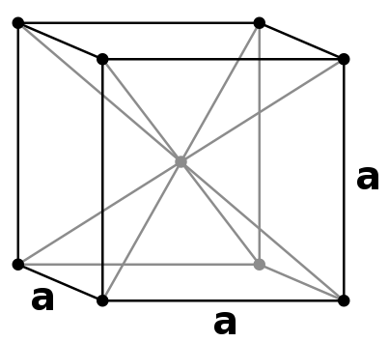
The face centered cuboid
Finally, the face-centered cubic has lattice points on the faces of the cube of which each unit cube gets exactly one half contribution, in addition to the corner lattice points, giving a total of 4 atoms per unit cell ((¹⁄₈ for each corner) × 8 corners + (¹⁄₂ for each face) × 6 faces).
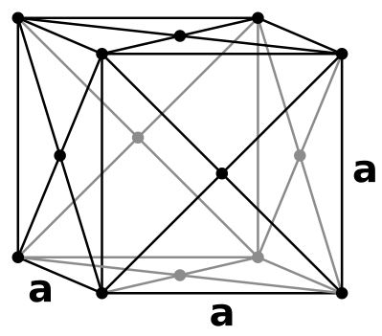

Crystal Structure
In mineralogy and crystallography, a crystal structure is a unique arrangement of atoms in a crystal. A crystal structure is composed of a motif, a set of atoms arranged in a particular way, and a lattice. Motifs are located upon the points of a lattice, which is an array of points repeating periodically in three dimensions. The points can be thought of as forming identical tiny boxes, called unit cells, that fill the space of the lattice. The lengths of the edges of a unit cell and the angles between them are called the lattice parameters. The symmetry properties of the crystal are embodied in its space group. A crystal's structure and symmetry play a role in determining many of its properties, such as cleavage, electronic band structure, and optical properties.
Source – wikipedia.org
The structure of metals
The structures of pure metals are easy to describe because the atoms that form these metals can be thought of as identical perfect spheres. The same can be said about the structure of the rare gases (He, Ne, Ar, and so on) at very low temperatures. These substances all crystallize in one of four basic structures: simple cubic (SC), body-centered cubic (BCC), hexagonal closest-packed (HCP), and cubic closest-packed (CCP).
The simple cubic packing
When a solid crystallizes, the particles that form the solid pack as tightly as possible. To illustrate this principle, let's try to imagine the best way of packing spheres, such as Ping-Pong balls, into an empty box. One approach involves carefully packing the Ping-Pong balls to form a square packed plane of spheres. By tilting the box to one side, we can stack a second plane of spheres directly on top of the first. The result is a regular structure in which the simplest repeating unit is a cube of eight spheres. This structure is called simple cubic packing. Each sphere in this structure touches four identical spheres in the same plane. It also touches one sphere in the plane above and one in the plane below. Each atom in this structure can form bonds to its six nearest neighbors. Each sphere is therefore said to have a coordination number of 6.
A simple cubic structure is not an efficient way of using space. Only 52% of the available space is actually occupied by the spheres in a simple cubic structure. The rest is empty space. Because this structure is inefficient, only one elementpoloniumcrystallizes in a simple cubic structure.
The body centered packing
Another approach starts by separating the spheres to form a square-packed plane in which they do not quite touch each other. The spheres in the second plane pack above the holes in the first plane. Spheres in the third plane pack above holes in the second plane. Spheres in the fourth plane pack above holes in the third plane, and so on. The result is a structure in which the odd-numbered planes of atoms are identical and the even-numbered planes are identical. This ABABABAB. . . repeating structure is known as body-centered cubic packing.
This structure is called body-centered cubic because each sphere touches four spheres in the plane above and four more in the plane below, arranged toward the corners of a cube. Thus, the repeating unit in this structure is a cube of eight spheres with a ninth identical sphere in the center of the bodyin other words, a body-centered cube. The coordination number in this structure is 8.
Body-centered cubic packing is a more efficient way of using space than simple cubic packing68% of the space in this structure is filled. All of the metals in Group IA (Li, Na, K, and so on), the heavier metals in Group IIA (Ca, Sr, and Ba), and a number of the early transition metals (such as Ti, V, Cr, Mo, W, and Fe) pack in a body-centered cubic structure.
The face centered cubic packing
In the Face Centered Cubic (FCC) unit cell there is one host atom at each corner and one host atom in each face. Since each corner atom contributes one eighth of its volume to the cell interior, and each face atom contributes one half of its volume to the cell interior (and there are six faces), then Z = ¹/₈.8 + ¹/₂.6 = 4.
The corner and face atoms touch along the face diagonal, and it is easy to show that the cube edge (a) is about 2.8r. Thus, the corner atoms do not touch one another.
The packing efficiency is about 74%. This is the maximum packing efficiency for spheres of equal radius and is called closest packing. Thus a face centered lattice of atoms is also called Cubic Closest Packing (CCP).

