Sodium, atomic structure. Caption: Sodium (Na). Diagram showing the nuclear composition and electron configuration of an atom of sodium-23 (atomic number: 11), the most common isotope of the element sodium. The nucleus consists of 11 protons (red) and 12 neutrons (blue).

Sodium, atomic structure - Stock Image C013/1517 - Science Photo ... 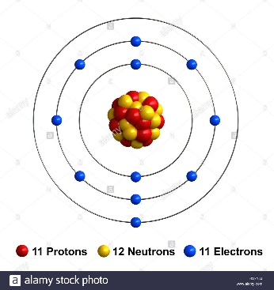

Hdpe Atomic Structure
Tuesday, December 5th 2017. | polyethylene
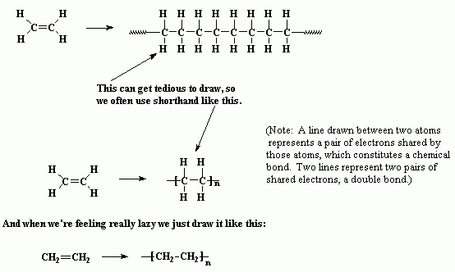

Diamond
Allotropes are forms of an element that exist in the same state (solid, liquid or gas) but have different properties because their atoms are arranged differently.
Diamond is one allotrope of carbon:
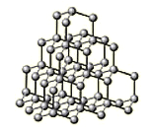
Diamond
Diamond's hardness and high melting point make it useful for cutting tools, such as the diamond-tipped discs used to cut bricks and concrete. Heavy-duty drill bits, like those used to drill through rocks in the oil exploration industry, are made with diamonds so that they stay sharp for longer.

Structure and bonding
Diamond has a giant molecular structure. Each carbon atom is covalently bonded to four other carbon atoms. A lot of energy is needed to separate the atoms in diamond. This is because covalent bonds are strong, and diamond contains very many covalent bonds. This makes diamond's melting point and boiling point very high.
There are no free electrons or ions in diamond, so it does not conduct electricity.

silicon carbide
Solid silicon carbide exists in many different crystalline forms, with the hexagonal crystal structure being the most commonly found one.
Structure of major SiC polytypes:

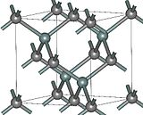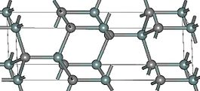

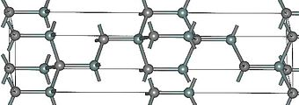
Added to iron to produce immensely strong material resistant to chemical attack.

