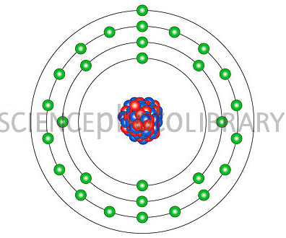
Copper, atomic structure. Caption: Copper (Cu). Diagram of the nuclear composition and electron configuration of an atom of copper atomic number: 29. The nucleus consists of 29 protons (red) and 34 neutrons (blue).

Atoms collect into face centred cuboids (FCC) to provide a malleable lustrous conductor of heat and electricity.
Copper is used in engineering for its conductivity, strength, and ability to be annealed but is considered to be costly for some applications.

