Find and store diagrams with their web address that show:
- necking
- micro-cavity
- example of 45° cup/cone for ductile fracture
- brittle fracture showing the granular, flat surface at 90° to the loading axis

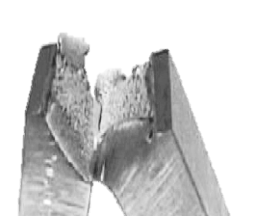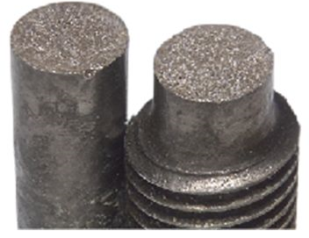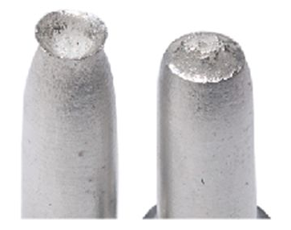
Figure 1 Figure 2 Figure 3
Figures 1 to 3 contain examples of the types of metal fractures required, this should help you to recognise the pictures.

