Task1- P1 Describe the structure and atomic structure of the following materials: Plain carbon steel 0.15%, HPDE, Silicon carbide, CFRP & piezoelectric

Plain Carbon Steel
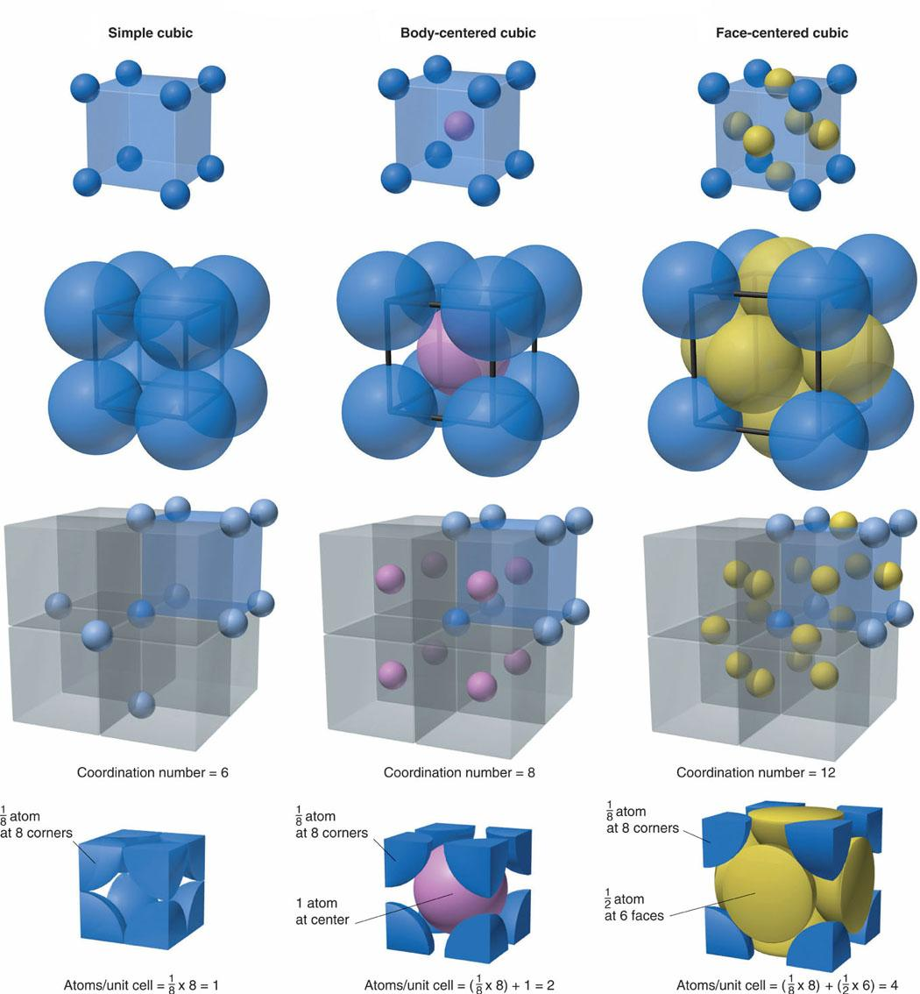
steel

carbon

Plain carbon steel is steel in which the main interstitial alloying constituent is carbon in the range of 0.12–2.0%. Steel is a metal and it is known as a refine iron. It has a controlled amount of carbon and when melted down with other minerals at specific temperature they removed impurities. Wrought steel is the end result of molten iron that has a carbon atoms bond to between 0.2- 0.8 percent. The reason for using plain carbon steel -0.15%c to make body panel for a car because steel is formed by dissolving carbon in iron. When heated at high temperature it forms a solid solution that is both malleable and ductile that can be rolled into thin sheets or hammered into various shapes.
Name: Iron
Symbol: Fe
Atomic Number: 26
Atomic Mass:55.845 amu
Melting point: 1535.0 degree Celsius
Boiling point: 2750.0 degree Celsius
Number of Protons/ Electrons : 26
Number of Neutrons:30
Classification: Transition metal
Crystal structure: cubic
Density @ 293k: 7.86g/cm3
Colour : silver

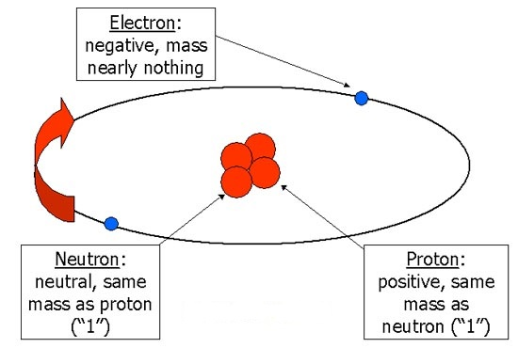
Atomic structure of plain carbon steel:

Steel is a refined form of iron that has a controlled amount of carbon added to it. It has also been smelted with various minerals to help remove impurities at specific temperatures. There are several grades of steel and other metals may be alloyed with the steel depending on what its eventual use will be. The smelting of iron into steel was developed to an efficient industrial process only in the 19th century.

HDPE
A linear polymer, High Density Polyethylene (HDPE) is prepared from ethylene by a catalytic process. The absence of branching results in a more closely packed structure with a higher density and somewhat higher chemical resistance than LDPE. HDPE is also somewhat harder and more opaque and it can withstand rather higher temperatures. HDPE lends itself particularly well to blow moulding. Good impact resistance, light weight, very low moisture absorption and high tensile strength. Polyethylene is the most common form of plastic and is used for drinks bottles, containers and plastic bags

HDPE Resistance:
-Excellent resistance to dilute and concentrated acids, alcohols & bases
-Good resistance to aldehydes, esters, aliphatic & aromatic Hydrocarbons, ketones & mineral & vegetable oils
Limited resistance to Halogenated Hydrocarbons & oxidizing agents

HDPE Facts:
Minimum Temperature: -148°F -100°C
Maximum Temperature: -248°F 120°C
Autoclavable: No
Melting Point: 266°F 130°C
Tensile Strength: 4550 psi
Hardness: SD65
UV Resistance: Poor
Translucent
Rigid
Specific Gravity: 0.95

Structure and atomic structure of high density polyethylene:
Heat process
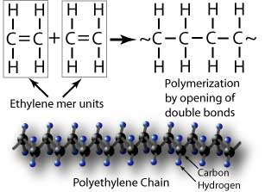

hydrogen carbon

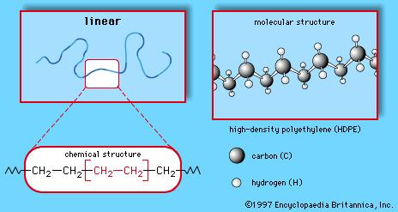

Silicon Carbide
Silicon carbide exists in about 250 crystalline forms. Silicon carbide is a hard covalently bonded material predominantly produced by the carbothermal reduction (Carbothermic reactions involve the reduction of substances, often metal oxides, using carbon as the reducing agent) of silica. It is formed using carbon and silicon which gives it great thermal properties. It can have a hexagonal or rhombic structure which is a-SiC, however its most basic structure is the diamond structure.

Structure and atomic structure of silicon carbide:
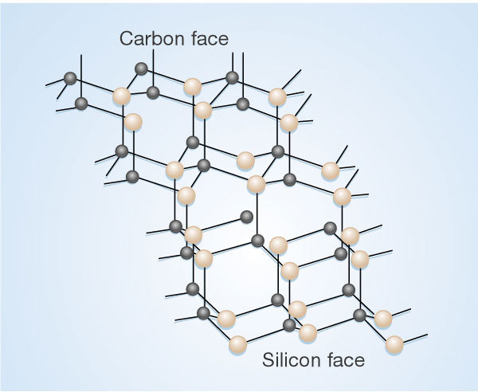
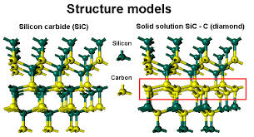
carbon silicon
Silicon carbide can be bonded together by sintering to form very hard ceramics that are widely used in applications requiring high endurance such as car brakes, car clutches and ceramic plates in bulletproof vests. Electronic applications of silicon carbide as LEDs and and today SiC is widely used in high-temperature/high-voltage semiconductor electronics.

Facts
other names: carborundum
MeSH: silicon+carbide
Molecular formula: CSi
Appearance: colourless crystals
Melting point: 2,730 °C
Density: 3.21 g·cm⁻³

CFRP
Carbon fibre reinforced polymer is a composite material as carbon fibre is the reinforcement and gives strength to the material whilst the polymer is the matrix that is used to bind the reinforcement together. The reinforcement will give the CFRP its strength and rigidity; measured by stress and elastic modulus respectively.

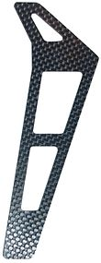

Tail of an RC helicopter made of CFRP
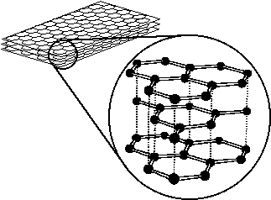

The carbon is bonded by itself which forms the hexagonal structure

Piezoelectric
The generation of an electric charge in certain non-conducting materials such as quartz crystals and ceramics, when they are subjected to mechanical stress such as pressure or the generation of vibrations in such materials when they are subjected to an electric field.

A piezoelectric disk generates
a voltage when deformed
(change in shape is greatly exaggerated)
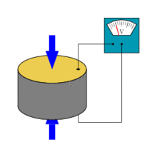
Structure of piezoelectric:
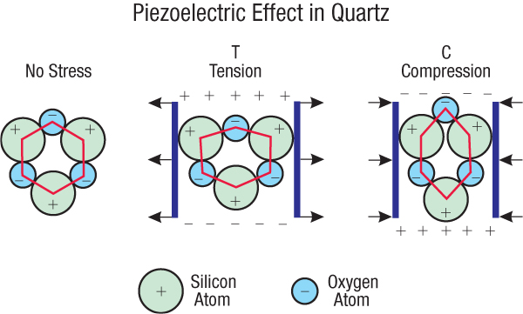

Task 2- P2 Classify each material as either metal or non metal and for each material state which properties most influenced you when making a decision

METALS | NON-METALS
Austenitic SS | Butyl
Copper | PVC- Polyvinyl chloride
Duralumin | Melamine formaldehyde (M-F)
 | CFRP
 | Piezo crystal
 | Diamond- Carbon
 | Porcelain

Austenitic stainless steel like other stainless steels contains mostly iron and some chromium so it is very definitely metal and also it does conduct heat and electricity.

Copper is a metallic element with a very high thermal and electrical conductivity. The copper metals have been used for many years in electrical and plumbing materials and a constituent for different metal alloys.

Duralumin is a hard, light alloy of aluminium with copper and other elements.

Butyl rubber is a synthetic rubber, a copolymer of isobutylene with isoprene. The abbreviation IIR stands for Isobutylene Isoprene Rubber.

Polyvinyl chloride is commonly used as the insulation on electrical cables; PVC used for this purpose needs to be plasticized so therefore can't be a metal.

Melamine formaldehyde is a hard, thermosetting plastic material made from melamine and formaldehyde by polymerization.

CFRP Carbon-fiber-reinforced polymers are composite materials. The composite consists of two parts: a matrix and reinforcement. In CFRP the reinforcement is carbon fiber which provides the strength. The matrix is usually a polymer resin such as epoxy.

Piezo crystal Also called piezoelectric crystals; Most piezo crystals in use today are made from polycrystalline ceramics which have better durability and flexibility than naturally occurring piezo crystals.
Diamond Diamond is pure carbon which is a non-metallic element

Porcelain is a ceramic material made by heating materials generally including clay in the form of kaolin

Task 3- P3
Describe; mechanical, physical, thermal, electrical & magnetic properties and pick 2 specific properties describe them & say why they are interest to a design engineer.
From each category pick 1 specific property and state its application in an engineering context.

-Mechanical
Ductility: Ability of a material to deform under tensile load. In materials science, ductility is a solid material's ability to deform under tensile stress; this is often characterized by the material's ability to be stretched into a wire. This is important to a design engineer because materials with time and force tend to strain with the load upon them which a design engineer needs to take consider carefully and take into account before designing anything.
Hardness: Hardness is a measure of how resistant solid matter is to various kinds of permanent shape and change when a force is applied. It's also Ability to withstand surface indentation. This would be interest to a design engineer because he'd take into consideration the hardness of materials and what they can withstand and what they cannot.

-Physical:
Elasticity: The tendency of solid materials to return to their original shape after being deformed. When an elastic material is deformed due to an external force, it experiences internal forces that oppose the deformation and restore it to its original state if the external force is no longer applied. If the material is elastic, the object will return to its initial shape and size when these forces are removed. In engineering, the amount of elasticity of a material is determined by two types of material parameter. The first type of material parameter is called a modulus which measures the amount of force per unit area (stress) needed to achieve a given amount of deformation. The units of modulus are Pascals (Pa) or pounds of force per square inch. A higher modulus typically indicates that the material is harder to deform. The second type of parameter measures the elastic limit. The limit can be a stress beyond which the material is no longer elastic or a deformation beyond which elasticity is lost.
Resistivity: This quantifies how strongly a given material opposes the flow of electric current. A low resistivity indicates a material that readily allows the movement of electric charge. Resistivity is commonly represented by the Greek letter ρ. The SI unit of electrical resistivity is the ohm-meter (Ω). A design engineer would need to know about the positive and negative traction current rails and resistivity so they would know how to calculate and install the correct materials in relation to conductivity, resistivity and electric current.

-Thermal:
Boiling point: The boiling point of a liquid is the temperature at which the vapour pressure of the liquid equals the pressure surrounding the liquid and the liquid changes into a vapour. A liquid in a vacuum has a lower boiling point than when that liquid is at atmospheric pressure. A liquid at high-pressure has a higher boiling point than when that liquid is at atmospheric pressure. In simple terms the boiling point of a liquid depends upon the surrounding environmental pressure. For a given pressure, different liquids boil at different temperatures.
Thermal expansion: This is the tendency of matter to change in volume in response to a change in temperature. When a substance is heated its particles begin moving more and thus usually maintains a greater average separation. Materials which contract with increasing temperature are unusual this effect is limited in size and only occurs within limited temperature ranges. The degree of expansion divided by the change in temperature is called the material's coefficient of thermal expansion and generally varies with temperature.

-Electrical:
Electrical conductivity: This is the ability of a material to conduct a flow of electrons and in due course is the reciprocal of electrical resistivity.
Permeability: This is the measure of the ability of a material to support the formation of a magnetic field within itself.

-Magnetic:
Curie temperature: The Curie temperature is the temperature where a material's permanent magnetism changes to induced magnetism. The force of magnetism is determined by magnetic moments. The Curie temperature is the critical point where a material's magnetic moments change direction. Materials have different structures of intrinsic magnetic moments that depend on temperature. At a material's Curie temperature those magnetic moments change direction.
Permeability: This is the measure of the ability of a material to support the formation of a magnetic field within itself. This would be of interest to a design engineer because permeability is an important parameter for magnetic materials used to make transformers, inductors and electric machines and the design engineer will need to know about the permeability of the materials before designing it.

Bibliography
http://en.wikipedia.org/wiki/Porcelain
https://www.google.co.uk/search?q=structure+of+carbon+steel&source=lnms&tbm=isch&sa=X&ei=T_EBU6mHOI2u4QSk74DIAg&ved=0CAcQ_AUoAQ&biw=1920&bih=951#q=atomic+structure+of+plain+carbon+steel&tbm=isch&facrc=_&imgdii=_&imgrc=KQLKeRDF858BIM%253A%3BLtD17BIpcf656M%3Bhttp%253A%252F%252Ftenerife-training.net%252FTenerife-News-Cycling-Blog%252Fwp-content%252Fuploads%252F2008%252F11%252Fhcp-fcc-bcc-close-packed-structures.jpg%3Bhttp%253A%252F%252Ftenerife-training.net%252FTenerife-News-Cycling-Blog%252Fcategory%252Flearning-curve%252F%3B1050%3B1134
http://en.wikipedia.org/wiki/High-density_polyethylene
http://en.wikipedia.org/wiki/Copper
http://www.gowelding.com/met/austenitic.html
http://lanxess.com/en/corporate/events/butyl-opening-singapore/what-is-butyl-rubber/
http://www.wisegeek.com/what-are-electrical-properties.htm
http://hyperphysics.phy-astr.gsu.edu/hbase/solids/magpr.htm
http://www.britannica.com/EBchecked/topic/544369/silicon-carbide
http://www.ndt-ed.org/EducationResources/CommunityCollege/Materials/Mechanical/Mechanical.htm
http://www.thefreedictionary.com/permeability
http://en.wikipedia.org/wiki/Polyvinyl_chloride

Task 4- M1
How do the properties and structure of the materials affect its performance

Plain carbon steel:
Plain carbon steel becomes less ductile and more brittle as the temperature is reduced however this is not a permanent effect because if heated the ductility will return. The degree to which ductility is lost at low temperatures depends to a great extent on processing variables such as composition and grain size. Most steel today should perform well at +32F. However at -50F only steel designed for low temperature service should be applied. In water whether near freezing or not it will be subject to an increased rate of corrosive attack. The worst that can happen is oxidation or rust because the water is not cold enough to change the crystalline structure of the metal to make it brittle. Therefore in extreme freezing conditions special steel should be used for example a steel that's specially designed for low temperatures to withstand the freezing temperatures to save the steel from oxidation or rust.
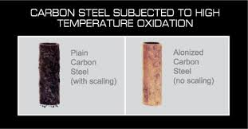

Carbon steel subjected to high temperature oxidation

Aluminium Alloy code 2024 age hardened also called Duralumin:
Duralumin is a strong, hard and lightweight alloy of aluminium. Their light weight and consequent high strength per unit weight compared with steel suit them for aircraft construction and because aluminium loses corrosion resistance when alloyed, a special laminated sheet form called alclad is used for aircraft construction; it has thin surface layers of pure aluminium covering the strong duralumin core.



Duralumin body of a passenger aircraft

Hep20 push fit (polybutylene):
Polybutylene has a semi-crystalline structure meaning its constituent atoms are bonded into a regular structure only over small areas. This reduces the strength of the polymer but assists in increasing its flexibility relative to plastics and other polymers of similar molecular size. Polybutylene consists of repeating units of four carbon and eight hydrogen atoms.
The negative side of using copper is it leaves traces of its material in drinking water and this can lead to Alzheimer’s heart disease. Copper is more expensive and easily damaged as acidic substances such as toothpaste can be harmful and cause patina the copper (tarnish the copper surface, i.e. oxidisation). There are other materials that can be used for pipes instead of polybutylene or copper such as brass. Polybutylene is cost effective, resistant to chemicals and hydrostatic pressure and also reacts to impact quite well. In other words polybutylene shows many more characteristics to be perfectly suitable for piping than copper.
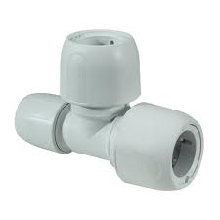

Hep20 polybutylene push fit

High carbon steel used in shear pins:
Shear pins are mechanisms used to prevent extensive damage on machinery. These components are made of high carbon steel because as the properties are different from other grades as when you increase the carbon content you increase the strength and hardness this in turn decreases the melting temperature and makes the material brittle. This is what you really want in a material for a job like this as it is still hard and strong enough to carry out its job but if unexpected loads are exerted upon it, it will break causing the machine to fail and stop working, preventing the machine from gaining further damage and injuring someone or causing excessive damage.
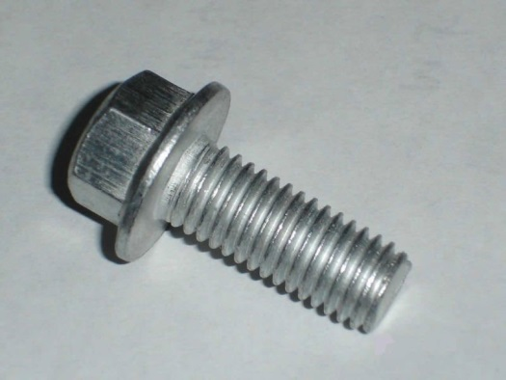

High carbon steel shear pin

Titanium alloy:
Titanium alloy performs well in an aircraft engine as its corrosion properties are close to that of platinum and its tensile strength is close to that found in alloy steels and its density is at least 50% less then steel. It performs well in high temperatures as it has a very high melting temperature and it also keeps its high tensile strength and toughness at such temperatures. It also has it high strength to weight ratio making it able to withstand stress. Grade 6 titanium is used in the construction of aircrafts as it has good weldability, stability and strength at elevated temperatures. Grade 6 titanium contains 5% aluminium and 2.5% tin.

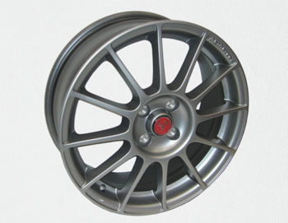

Titanium alloy wheel

