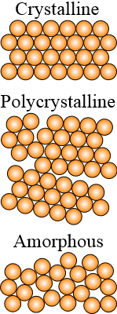
Recrystallisation

Heating a material beyond its critical temperature causes the crystals to deform and reform – it is the rate of cooling as well as the temperature that the cooling rate changes that determines the properties of the new material.

Recrystallization is a process by which deformed crystallites of different shapes and sizes (grains) are replaced by a new set of undeformed grains that form into a new structure (nucleate).

This recrystallisation of the material will usually result in a reduction of strength and hardness while at the same time increasing its ductility. This process is called annealing – material is heated close to melting point and then allowed to cool very slowly.

- hot or cold working
- alloying

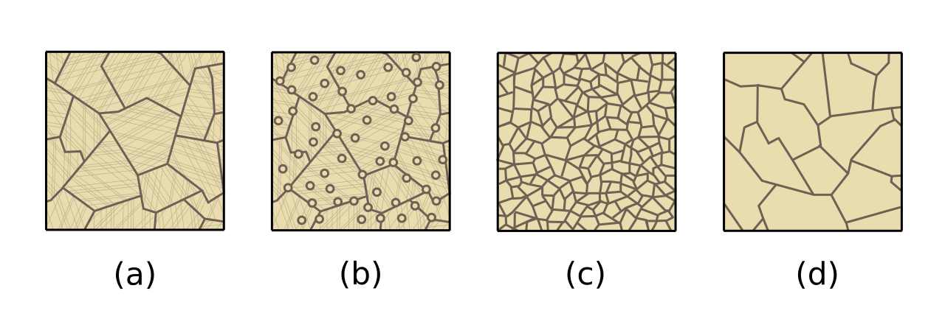
"Ricristallizzazione e accrescimento" by Aushulz
In these sketches the panels a and b show recrystalisation and b, c and d show the crystal grain growth.

