Task 1:
1)
BBQ:
I have decided to use cast iron for my grill part and charcoal burner of the BBQ. Cast iron has a carbon content of 2% or more. Its most useful characteristic is its low melting temperature. Cast iron is of generally high quality however people do find that the heavy weight of the cast iron dangerous. Another con is that when cast iron is untreated it can start to rust due to heat and environment. Another type of cast iron is porcelain coated cast iron, this is the slightly more expensive option, and it can also protect the cast iron gate from rust prolonging its life span.
It is more durable than chrome gates but not as durable as stainless steel which has a warranty covered stainless steel. To avoid rusting you can cover in oil either it is susceptible to rust over time.
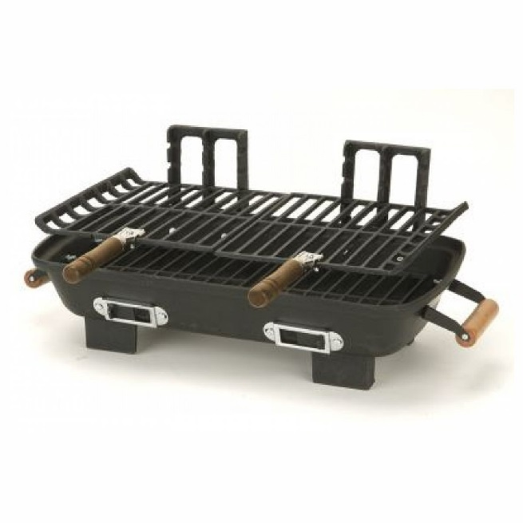
Source of Image: https://www.pricefalls.com/product/Hibachi-Charcoal-Grill-with-Cast-Iron-Grill-Grids/7771384

Kid’s computer:
I have decided to use a thermosetting material polyester fibreglass. Thermosetting polymer is a prepolymer that when liquid or soft solid can only be shaped once by curing unlike thermoplastic than be reshaped over and over again. The particular thermosetting material I would use is fibreglass which is a fiber reinforced plastic, the particular fiber being glass. As kids don’t respond to the black or silver and would like a more colourful approach, the pigmentation can be mixed with the prepolymer when it is liquid and then cured into a solid. Fiberglass is a strong lightweight material and less brittle making it ideal to be used in this case.
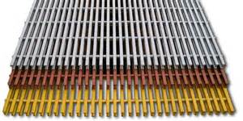
Source of Image: http://nationalgrating.com/pultruded-fiberglass-grating-i-4000-4ft-x-20ft-x-1-inch

Sources for Task 1:
https://en.wikipedia.org/wiki/Fiberglass
https://en.wikipedia.org/wiki/Thermosetting_polymer
https://en.wikipedia.org/wiki/Cast_iron
http://www.stephensinjectionmoulding.co.uk/thermoplastics/

Task 2:
(1)
The recrystallization of iron and steel is when old and deformed grains are replaced by new undeformed grains which grow until the old grains are fully replaced. When recrystallization happens the strength and hardness of iron and steel is reduced, at the same time the ductility of iron and steel increases. Recrystallization is usually a part of the processing of iron and steel. Recrystallization of metals all have a critical temperature which is the minimum temperature the right atomic mechanisms to happen. There are different things that affect the rate of the critical temperature, which is deformation and initial grain size. The recrystallization temperature of steel is 0.45 times it melting point so the melting point of common steel is around 1450C. So recrystallization temperature would be 0.45x1450C=653.5C. The recrystallization temperature of iron is 723 Celsius. The hot working of steel would be when it is plastically deformed above 635.5C which is above its recrystallization temperature. The recrystallization of iron is when this is done above 723 Celsius. This allows recrystallization during deformation. Cold working of iron and steel is when it is put under enough stress that it causes plastic deformation which causes a permanent change in the crystalline structure. Alloying is when a metallic sold is a mixture of two or more metals or of metals and non-metal or metalloid elements. Steel is almost always an alloy with its most common one being mixed with carbon. It is the main alloying part of carbon; carbon is contained by 0.12-2%.
(2)
Thermoplastic materials are polymers that become able to be moulded above a certain temperature, they usually have good dimensional stability, tendency to brittleness and low chemical resistance. Acrylic are known for their resistance to breakage and elasticity. The polymer processing temperature of acrylic is around 100 to 500 Celsius. Polyethylene is the most common plastic; it is usually a mixture of polymers of ethylene with different values of n. Its polymer processing temperature is 200 Celsius. Injection moulding is when molten plastic is injected into mould which is compressed and cooled this is what happens to acrylic and polyethylene.
(3)
Mould temperature has a profound effect on final properties, in polymers such as ABS and polycarbonate there are lower levels of molded in stress due to higher mold temperatures and this causes better stress crack resistance and impact resistance. Curing temperature is the temperature an adhesive must be subjected to in order for it to cure satisfactorily. Too low of a cure temperature will result in slow cure and too high can cause the system to expand rather than shrink. Mould pressure is when the moulding material is placed in a mould cavity where it is closed with top force and pressure is applied.
(4)
Pottery is a ceramic material, an inorganic, non-metallic solid material. It is made when forming a clay body into object of wanted shape and heating them up to high temperature which removes all the water from the clay. Firing produces irreversible changes in the body. It is only after firing the material is pottery. Porcelain is a ceramic material made by heating materials; usually kaolin. Green ceramic wares are heated to high temperatures in kiln to set their shapes permanently. The water content of clay causes it to be cohesive or sticky.
(5)
Concrete is a composite material formed from coarse bonded with fluid cement. Fibre-reinforced plastic is a composite material formed from a polymer matrix reinforced with fibres. The delamination of these composites is a way of to know failure in composites, delamination failure can be found through sound etc. Delamination occurs in concrete structures exposed to reinforcement corrosion. Matrix composites is a composite material with 2 or more constituent materials. These are made in concrete and Fibre reinforced plastic by dispersing a reinforcing material into a metal matrix. Cermet usually has hard oxide or carbide particles in metal matrix, dispersion is when the hard particles are well dispersed if they space themselves out through the metal and avoid coalescing.

Task 3:
Plain carbon steel:
Carbon steel can resist cold better than many other materials due to the carbon element. So exposure to low temperature does not have any sudden effects to the material. However after a certain point such as below freezing hardened steel can become brittle which makes it liable to break easily which is not the desired effect you would want in the construction of ship hulls. This was a problem the US liberty experienced during World War II (1) “U.S. Liberty ship crews found this problem out the hard way as hulls strained by cargo began to split up at the seams when travelling through cold Atlantic waters in World War II”. Carbon steel has to undergo mixing with other materials to maintain flexibility.
Source (1): http://www.ehow.co.uk/info_8672716_lowtemperature-effects-carbon-steel.html

Duralumin:
During the 1920s and 1930s using Duralumin became a wartime secret due to it being a low density alloy, giving it a high strength to weight ratio. It is mainly made out of aluminium (93.5%) developed to give it a low corrosion and low fatigue making it strong and lightweight. The reason certain parts of the aircraft has a finite life it is down to the fatigue life of the structure. The fatigue because during every flight the aircraft is pressurized and then has to be depressurized causing it to fatigue ( the build-up and growth of tiny cracks over the duralumin structure).

Polybutylene:
The main use of PB-1 is in the use of pressure piping systems. It is used because of its resistance of temperature, weldability, no corrosion etc. PB-1 is more flexible than copper. One of the main reasons for the use of PB-1 over copper is its low cost and easily installation which is preferred by plumbers. However PB-1 structure has been found to weaken over time due to the oxidants in the water altering the chemical structure.

High carbon steel:
High carbon steel is stronger than low carbon steel due to heat treatment making it able to fail at a much higher load which is why it is used in sheer pins. It has high hardness and low toughness, this makes it ideal for when wear resistance is important. Compressive loading minimize brittle fracture that might develop on tensile loading.

Titanium alloy:
Titanium alloys have a high tensile strength and toughness even at extreme toughness. Titanium’s melting point is very high at 3000 degrees Fahrenheit which makes it able withstand high heat environments. It also withstand long periods of salt water which makes it valuable in coastal areas. It is also non-magnetic and does not conduct heat and electricity. It also has a high strength to weight ratio, is reliable and has good corrosion resistance.

Task 4:
Cast iron has a relatively good thermal conductivity, this is the “(1). The rate at which heat flows through a material between points at different temperatures, measured in watts per meter per degree”. This makes it good for BBQ plates so they heat up well enough. It also holds heat longer than most materials. However cast iron has a different crystalline structure from mild steel, this makes it less dense and more porous. Cast iron also has a worse heat retention than mild steel than mild steel because of its porous nature, this causes the BBQ plate to lose heat at a greater rate. However cast iron gets up to temperature quicker than mild steel even though mild steel uses less energy to retain that temperature. Cast iron has a low melting temperature. Cast iron also has good fluidity, good machinability, resistance to deformation and wear resistance. Cast iron can also be used in the liquefied petroleum gas (LPG) grill and the traditional charcoal burner whereas mild steel is used for the BBQ plates. A problem people may face when using cast iron BBQ is that it is quite heavy and that may be a problem as this is an outdoor BBQ and a lot of people tend to put their BBQ in the shed which may be dangerous because of how heavy it is.
(1) http://www.bing.com/search?q=thermal+conductivity+definition&src=IE-SearchBox&FORM=IESR02
Thermosetting polymer is a prepolymer that when liquid or soft solid can only be shaped once by curing unlike thermoplastic than be reshaped over and over again. The reason I picked the thermosetting material polyester fibreglass was its ability when liquid or soft solid to be able to mix pigment in the liquid. The computer manufacturer specified that children favour coloured casing rather than the black or silver one so that is one of the main reasons I chose fibreglass. Fiberglass is also a strong lightweight material and less brittle making it ideal to be used in this case. This was one of the main reasons I chose fibreglass over aluminium as even though it has low density and is resistant to corrosion, is soft durable and lightweight, it does not contain the ability to be mixed with pigment. Aluminium is also expensive, to keep costs down manufacturers try to use as little aluminium as possible which causes the casing to be more fragile. The reason I also chose fibreglass over steel is that even though they are less likely to scratch, is thick and durable. It can also be sound proof. The problem with steel is that it is very heavy and chunk. So this may not be ideal for someone who takes their computer around. It also isn’t a very good heat conductor.
Even though fibreglass may not be the most durable of materials or most lightweight I used the computer manufacturers main point which was that the computer casing should be a bright colour so that it appeals to children. So that is why I chose fibreglass with its ability to be mixed with pigment when a liquid or soft solid.

