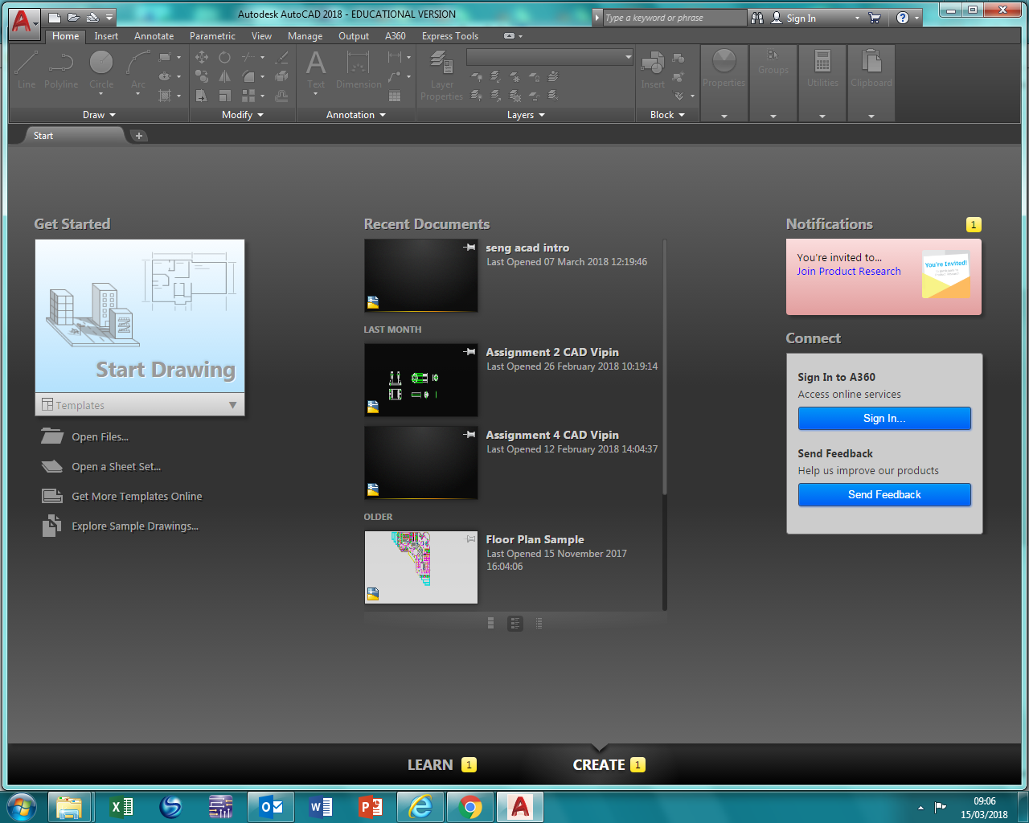
Click on “Start Drawing” and wait, quite a while for the first time…
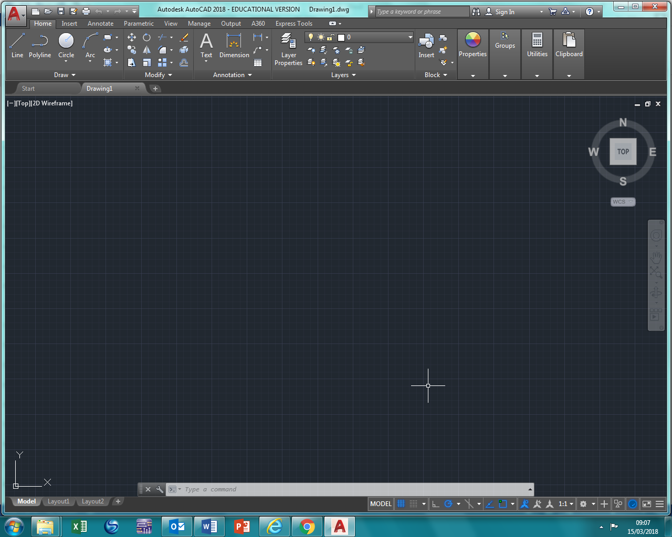
This is the “Model Space” here is where we draw our design… lets start with learning about “Snaps”

