FORM AB1: BTEC ASSIGNMENT BRIEF  QCF ASSIGNMENT FRONT SHEET | 

Qualification |  |  |  | Unit number and title
Level 3 Diploma in Engineering |  |  |  | 17. Computer Aided Drafting
Learner name |  |  |  | Assessor name
 |  |  |  | Jim Gillain
Date issued |  |  | Hand in deadline |  | Submitted on
Assignment title |  | Advantages of Computer Aided Drafting (CAD)
In this assessment you will have opportunities to provide evidence against the following criteria. Indicate the page numbers where the evidence can be found.
Criteria reference | To achieve the criteria the evidence must show that the learner is able to: |  |  |  |  |  | Task no. |  |  |  | Evidence
P1 | describe the advantages, compared to other methods, of producing drawings electronically using a CAD package |  |  |  |  |  | 1
P2 | describe the software and hardware required to produce CAD drawings |  |  |  |  |  | 2
P4 | using appropriate commands, produce a circuit diagram containing at least five components to appropriate standards |  |  |  |  |  | 5
M1 | explain the relationship between CAD and other software/hardware used in manufacturing |  |  |  |  |  | 4
D1 | justify the use of CAD in a manufacturing company |  |  |  |  |  | 3
Learner declaration
I certify that the work submitted for this assignment is my own. I have clearly referenced any sources used in the work. I understand that false declaration is a form of malpractice.

Student signature: Date:

Purpose of this assignment:

To describe the uses and advantages given to manufacturing/industry by using CAD for engineering communication and simulation.
Scenario

You are justifying the use of CAD and your own PC designed to produce CAD and drawings to your employer.
Task |  |  |  |  |  |  |  | This provides evidence for [e.g. P1, M1, D1]
Task 1  Describe the advantages of using computer aided drafting (CAD) over: 1) hand drawing, and 2) simple sketching. Remembering that the idea of drawings is to communicate engineering information between engineers in different offices, in different countries on differing continents.  Word limit 500 aim for 250 |  |  |  |  |  |  |  | P1
Task 2  A modest computer “off the shelf” can be used for CAD; describe a desk top personal computer (PC) that would be ideal for CAD, include the specification for graphics, memory, input and output devices; think of this as an opportunity to produce a shopping list for your ideal CAD set up. |  |  |  |  |  |  |  | P2
Task 3  Write a compelling description for using CAD in your own industry or any manufacturing company, in a way that justifies the expense of your PC in task 2.  Word limit 500 aim for 250 |  |  |  |  |  |  |  | D1
Task 4  CAD is widely used in manufacturing and its uses are not limited to drawing. Explain the other uses of CAD in manufacturing and its interfaces with other software.  Word limit 500 aim for 250 |  |  |  |  |  |  |  | M1
Task 5  The circuit diagram below is to be sent to the prototyping workshop, it first has to be drawn properly in CAD using appropriate software (MultiSim). It is missing a 12V battery for supply, ground for 0V, input and output connectors; add them in your drawing.  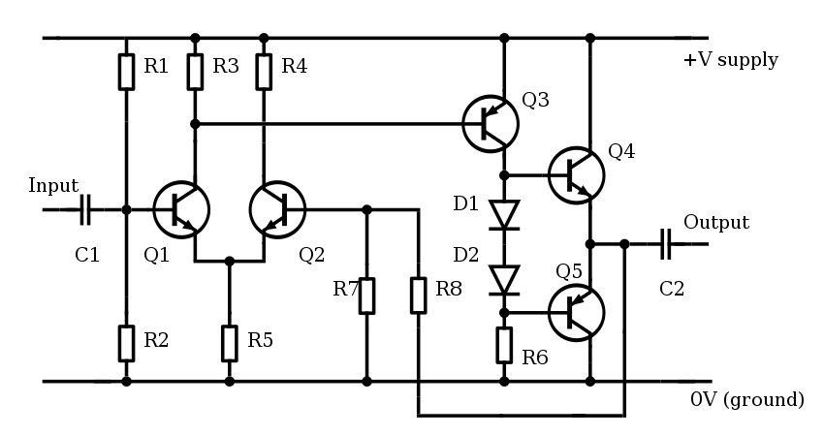  The circuit drawing should comply with ISC 60617 or BS 3939 |  |  |  |  |  |  |  | P4
Evidence checklist: [e.g. ‘leaflet’, ‘presentation notes’ etc.]
 |  |  |  |  |  |  |  |  | [tick boxes]
Sources of information: (e.g. publications, websites etc.)
Use Moodle…

