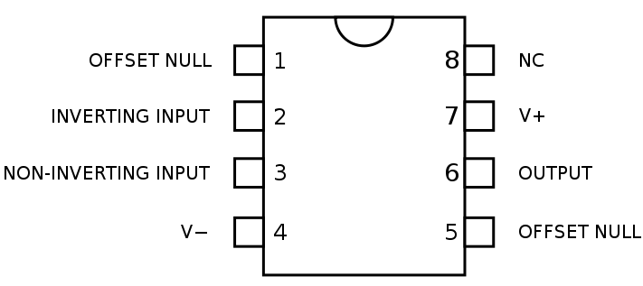
Aim
- To build the op-amp and test it with a range of inputs
- To record the performance of the op-amp at several frequencies and with several input voltages
- To record all aspects of building and testing the circuit

R2 and R3 should be changed and the gain of the amplifier re-tested. R1 and R2 can also be changed to demonstrate another voltage gain.

Equipment:

Usual tools and wires
Two power supplies
An oscilloscope with test leads
One function generator

One op-amp kit of parts

Recording sheet

Name: ________________________________________

Date: _________________________________________

Input voltage  (p-p) | Output voltage  (p-p) | Input frequency | Output phase | Distortion

